**Client Meeting #1 (Requirements)**

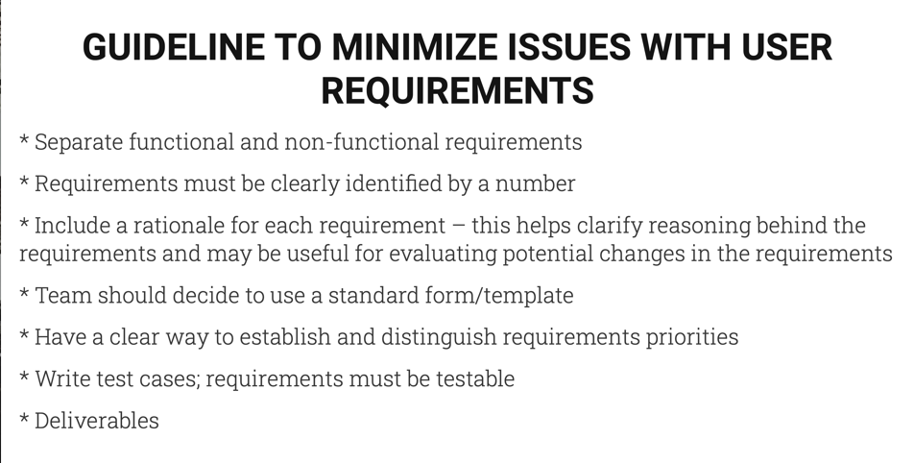

*Questions*:

1. What specific goals do you want users to achieve using this app?
   1. Maps for walking trail
   2. Who is using and how often which videos
   3. Leave reviews by liking or disliking
2. Any main problems the app should solve? (Pain points or challenges that the app should address)
   1. No links to videos yet
   2. Animated videos
3. What main things should the app do?
   1. Touch spots along trail and see different videos
   2. focus is video
4. Are there any additional features you'd like to include?
5. What core features do you envision for the app? (e.g., GPS tracking, distance measurement, route planning)

*for reqs, higher in the list = higher priority

*Functional Requirements*:



*Non-functional Requirements*:

*Deliverables*: